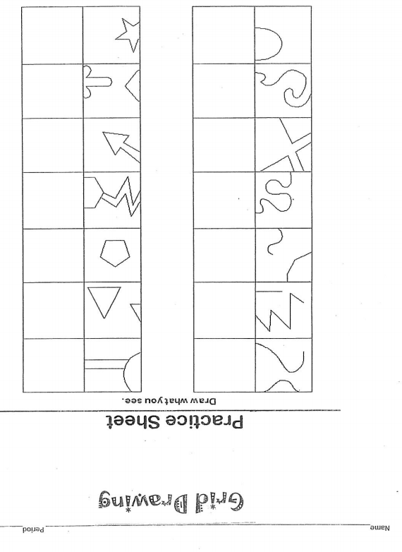
Directions: Letter and number the grid below. Enlarge the elephant by drawing box by box what you see. Draw slowly and consistently look back and forth between the two drawings!
