Drawing & Painting I
Mrs. Conte
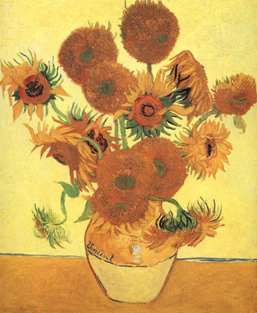
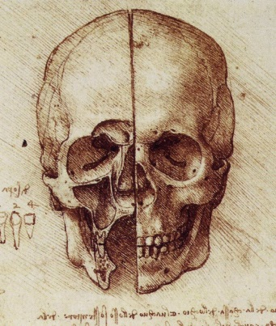
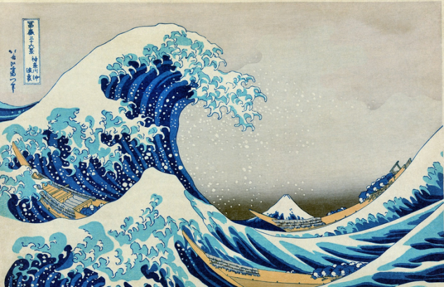

“Learn the rules like a pro, so you can break them like an artist.”
-Pablo Picasso

The nature of art is to open up a world of possibilities. You are adding to the world with your own creations. This is a great and exciting responsibility!

With all of the knowledge you will gain during this course and all of the exploration that will take place, there are certain expectations that also exist.

- Take risks – Being reserved and hesitant will not stand in any aspect of art. You must run the risk of failing if you are to succeed.

- Be independent – Come up with wild solutions to the posed problems and also create challenges for yourself.

- Be prepared – Make sure you have the materials necessary to produce. Take advantage of the limited time you have in the studio.

- Participate – You will be as much of a help to your classmates as they are to you. Participation is not only fulfilling the requirements of the class but also being a part of the environment.

- Explore – Do not simply do what is familiar and comfortable. Seek out new ideas and new information. Allow yourself to grow.

- Have ambition – Settle for nothing but your best.
ConteArt.Weebly.com

Your evaluation will be based on: Class Participation
Craftsmanship
Work ethic
Creativity
Conduct
Time management
Completion of assignments

